Snakes and How They Get Energy
Curriculum materials prepared by John Henry, Alan Johnson and Carl Toler
Illustrated by Stephanie Cooper, Elijah Schell, Rachel Stowe, Stephanie Tullis and Kennedy Young-Moore

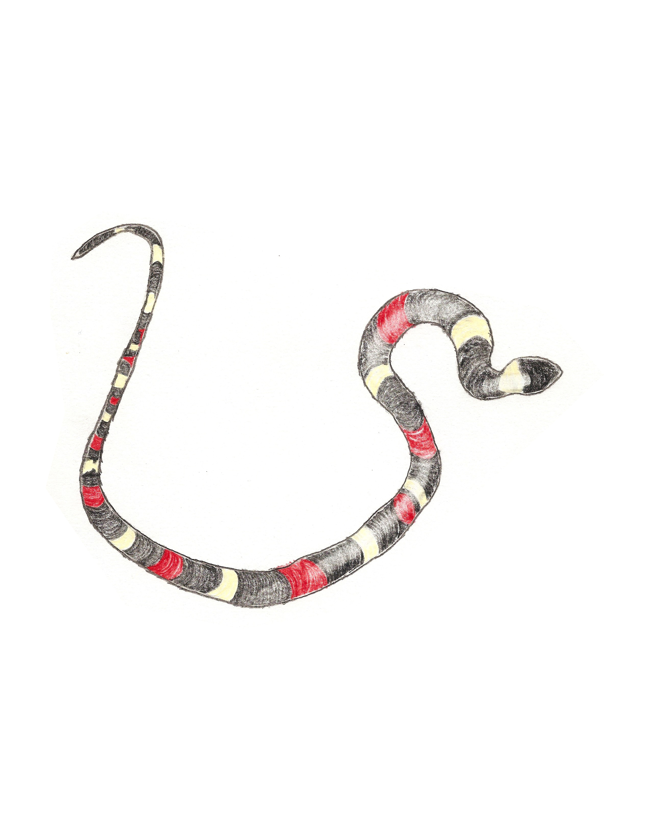

Engage
Food webs/chains
Explain how energy from the sun gets to all living things. You can draw a food web or write a few sentences if you want, as long as it is clear how the energy is transferred.
Consider these things while you are answering this question:
- How does the energy from the sun get to plants?
- How does the same energy get to a carnivore?
- Do animals get the same amount of energy from the sun as plants?
______________________________________________________________________________
______________________________________________________________________________
______________________________________________________________________________
______________________________________________________________________________
______________________________________________________________________________
______________________________________________________________________________
______________________________________________________________________________
______________________________________________________________________________
______________________________________________________________________________
______________________________________________________________________________

Explain

Everything in a rainforest is connected. Everything depends on each other for life. If something messes up that system, then every plant and animal in the rainforest is affected by it.
Snakes help keep the rodent population of various rainforests and other places around the world in check. Rats and mice eat a variety of plants like seeds, grains, and nuts. If snakes aren’t there to hunt them, mice and rats would quickly consume the supply of food. That would leave other animals that need it to starve.

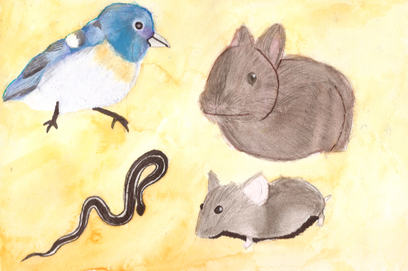

Snakes also contribute to the rainforest ecosystem as prey. Plenty of animals depend on snakes as part of their diet. Mongoose, eagles and other birds of prey eat snakes. Bigger snakes also hunt smaller snakes. Another way they help the ecosystem is simply by living there. When a snake dies, its body decomposes and the nutrients in it help future plants and animals grow. This whole system is called an ecosystem.
Elaborate
SNAKE HUNTING STYLES
What are the differences between the two snakes below? Try and focus on the mouths.

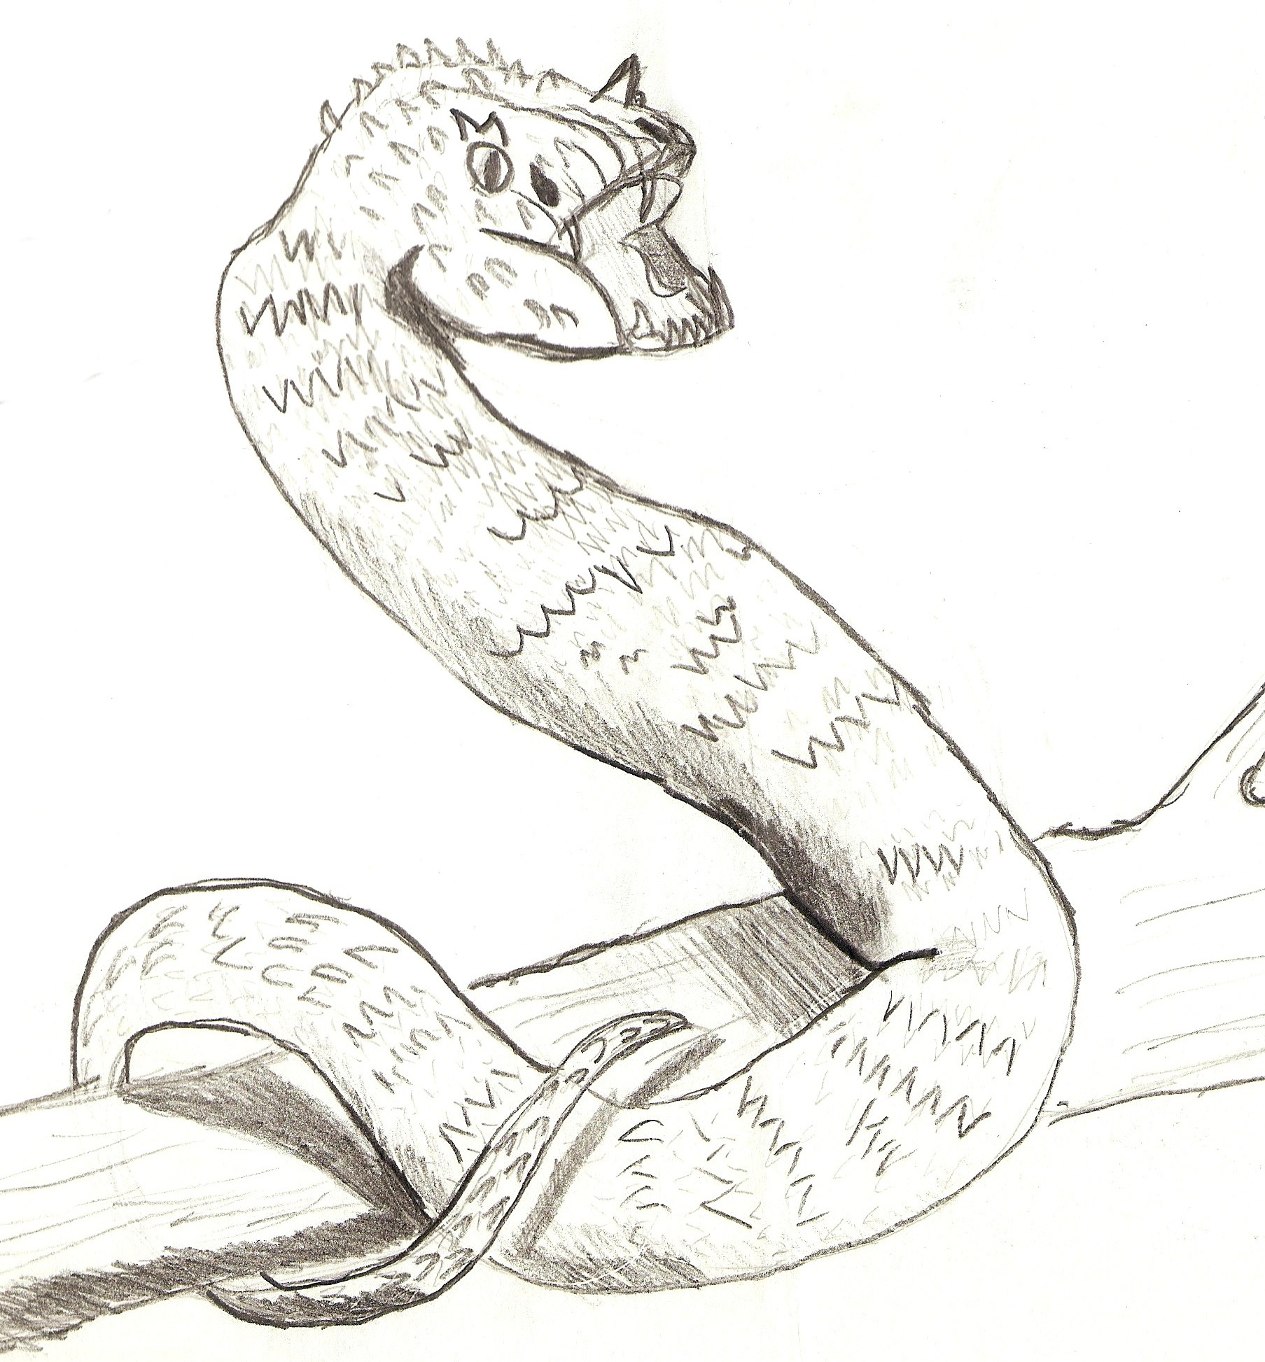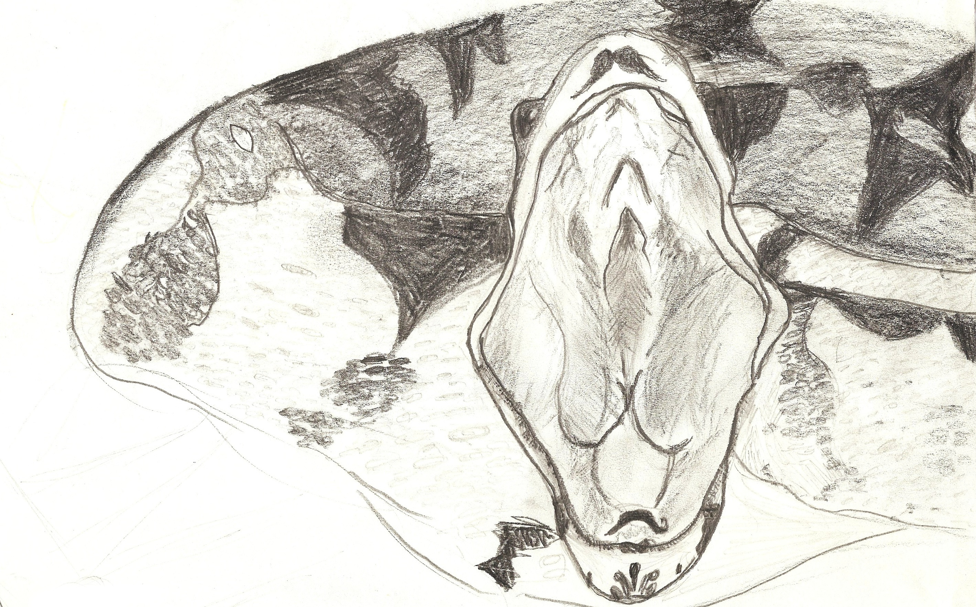

The reason for these differences are the way they eat their prey. The Eyelash Viper (left) is a venomous snake, while the Red Tailed Boa (right) is a constrictor snake. Notice the differences in their mouths. The Red Tailed Boa doesn’t need fangs since it strangles its prey, while the Eyelash Viper uses its deadly fangs to inject poison into their prey to help consume them.

A tentacle snake eats a fish

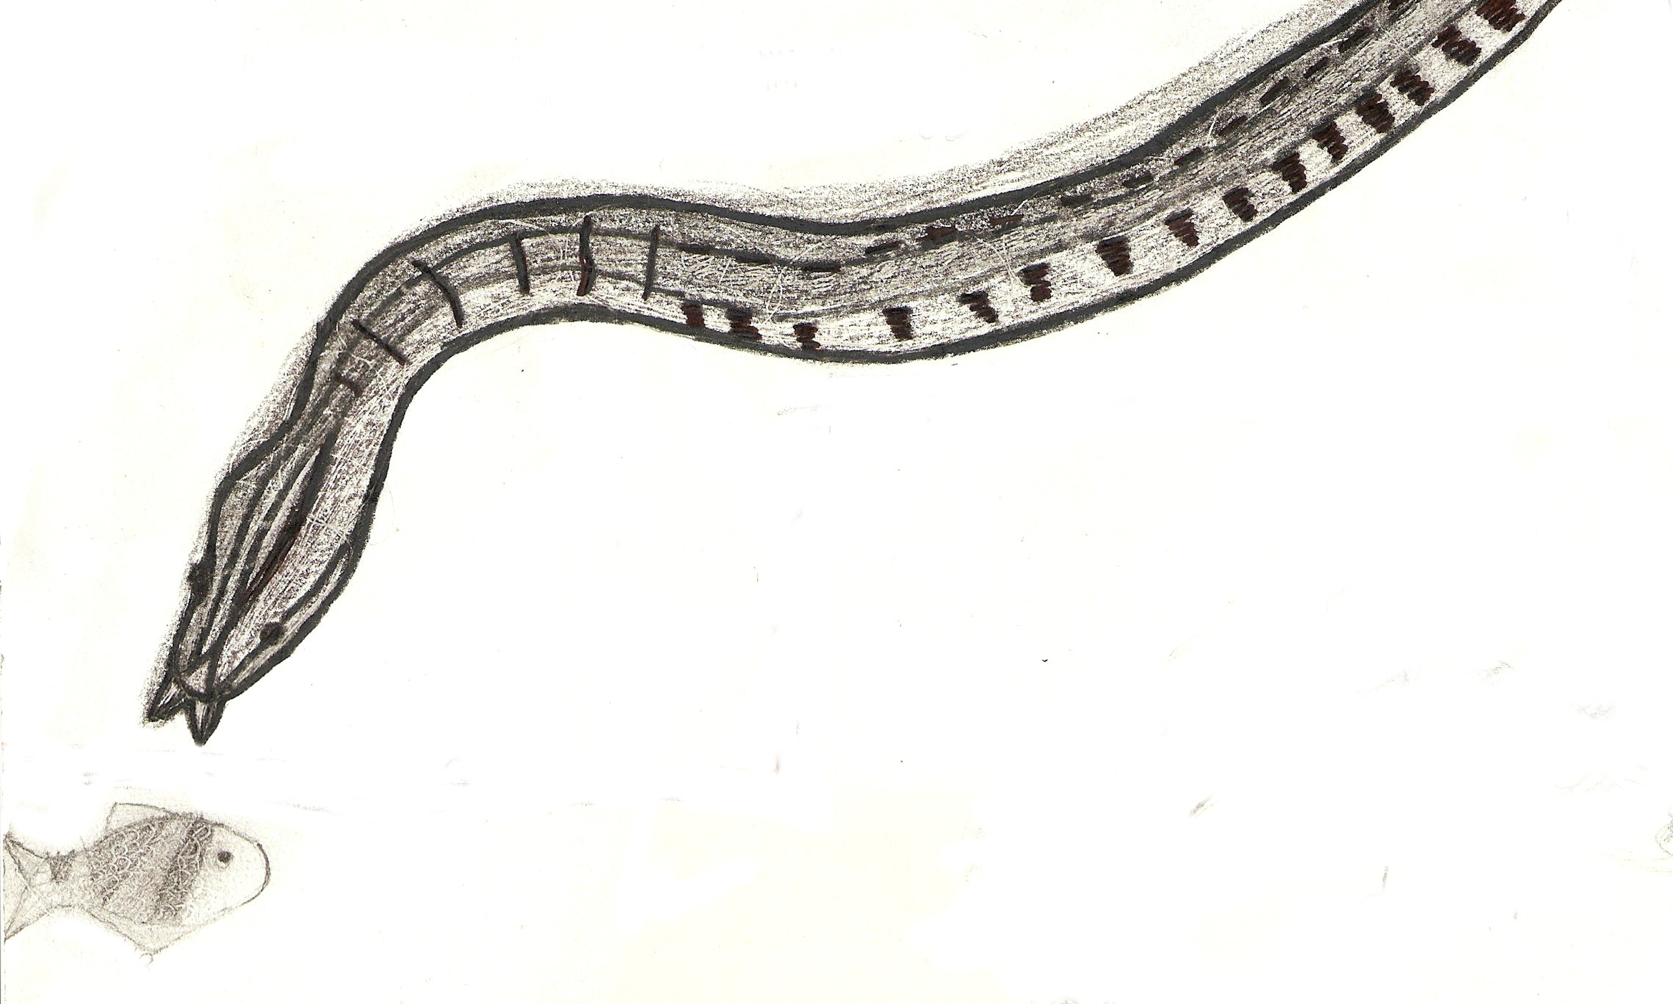
According to this picture, do all snakes eat mammals, or is there a variety in different snakes’ diets?
_____________________________________________________________________________
______________________________________________________________________________
______________________________________________________________________________
______________________________________________________________________________
______________________________________________________________________________

How do snakes get their energy?
There are snakes which have special adaptations. Adaptations are trait variations that help an animal live in its environment; these adaptations are special to where they live. For example, tentacled snake has an adaptation for living in water.
The tentacled snake also has small tentacles on the tip of its head to “feel” the water move. The tentacles help the snake find its prey. Unlike other snakes that eat mammals, tentacled snakes only eat fish to get their energy.
There are also differences in the way snakes look. These differences help snakes stay unseen from predators, and they help with hunting their prey. For example, the tentacled snake has light tan/green skin to help it blend into the twigs and branches where it hides. Most snakes lie in wait for their prey to ambush them, which helps snakes get energy.
Snakes get energy by eating other animals. The animals they eat are separated into categories. These categories are herbivores and carnivores. Herbivores eat only plants to get energy, and carnivores eat only animals to get energy. There are also omnivores, which eat both plants and animals.
All of these animals are called heterotrophs. Heterotrophs do not make their own food, but by eating animals that eat plants, they can get the energy from the sun. Snakes don’t get as much energy as herbivores from the sun, so they have to eat more to get the same amount of energy.

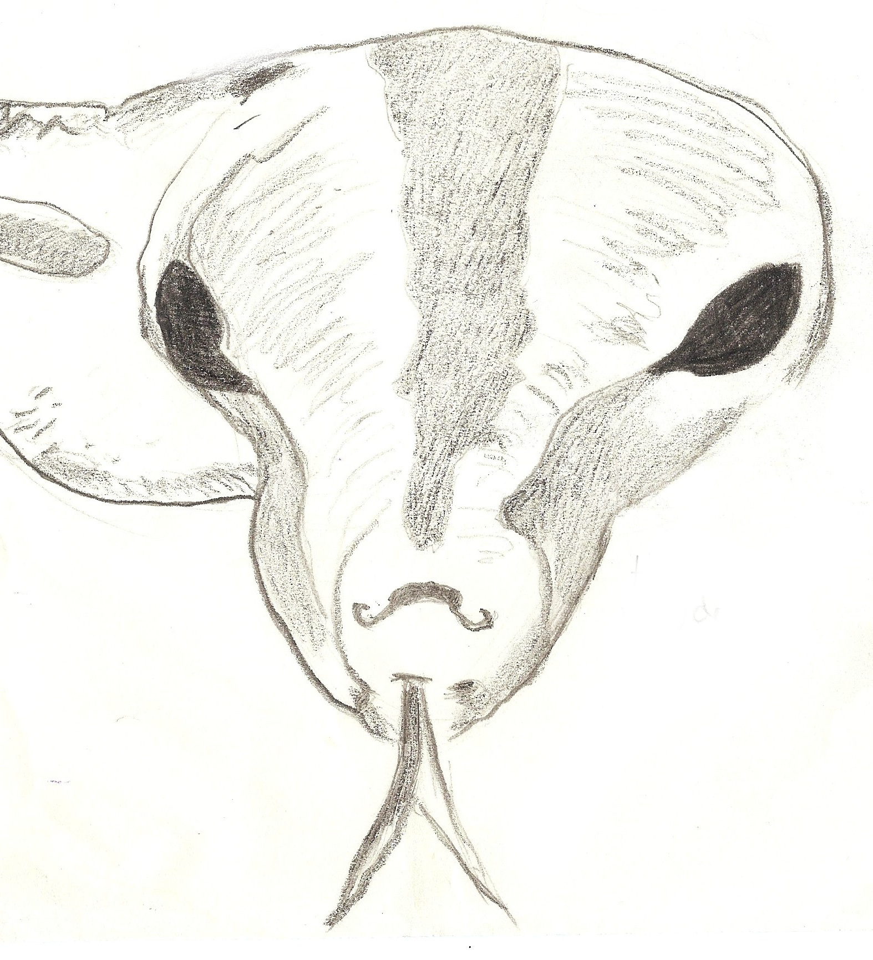

EVALUATE
Write a few sentences on how a food web works and how snakes are included. Also include how snakes are important in an environment. ______________________________________________________________________________
______________________________________________________________________________
______________________________________________________________________________
______________________________________________________________________________
______________________________________________________________________________
______________________________________________________________________________
______________________________________________________________________________
______________________________________________________________________________
______________________________________________________________________________
______________________________________________________________________________
______________________________________________________________________________

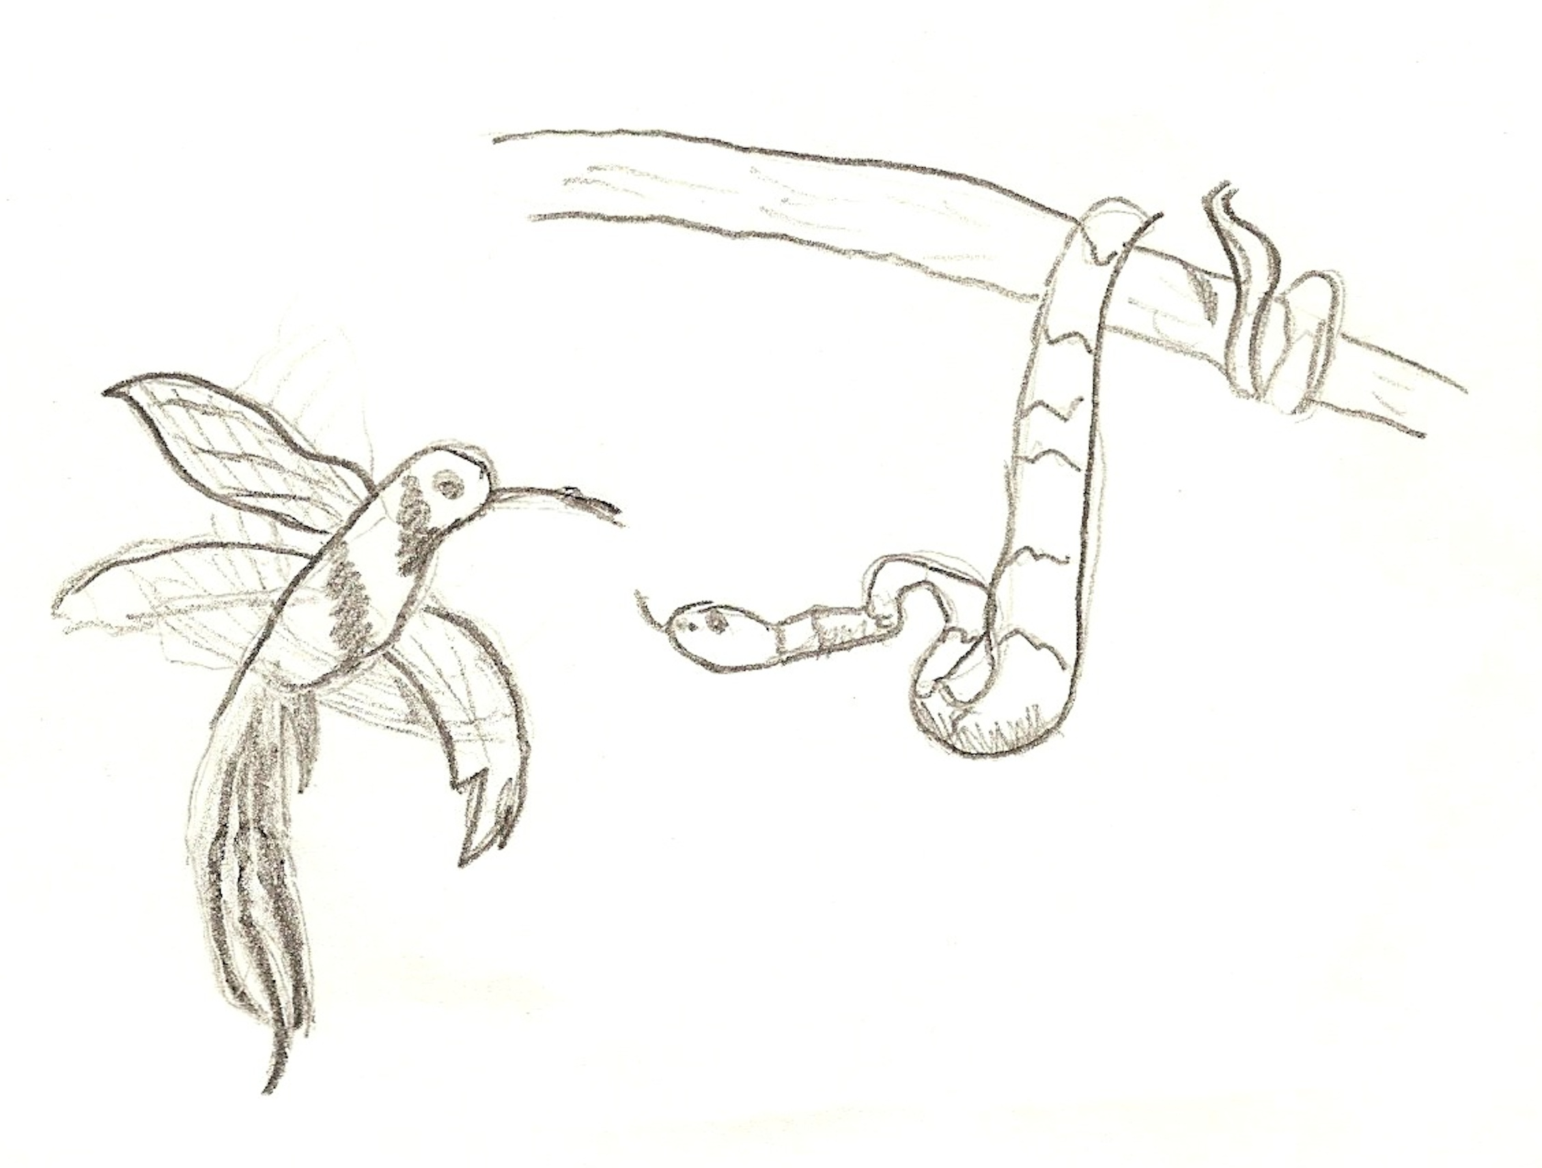

References
BioDiversityExplorer. (2004). Bitis gabonica (gaboon adder, central african gaboon adder). Retrieved from http://www.biodiversityexplorer.org/reptiles/squamata/serpentes/viperidae/bitis_gabonica.htm
Fort Wayne Children’s Zoo. (2014). Tentacled snake. Retrieved from http://kidszoo.org/our-animals/indonesian-rain-forest/tentacled-snake/
Marietta College. (2014). The tropical rain forest. Retrieved from http://www.marietta.edu/~biol/biomes/troprain.htm
Melissa Kaplan. (1994-2014). Red tailed boa care. Retrieved from www.anapsid.org/boa.html

FOR TEACHERS ONLY
EXPLORE
Explore Food Web
This activity will take place after the engage activity.
For this activity, you will need to cut out the slips of paper with an animal on it. There is a list below (make sure you print it one sided). You will need post-it notes, a ball of string, scissors, and a reasonable amount of room to roam about.
In this activity, you will be doing a much larger version of a food web.
BEFORE YOU DO THIS ACTIVITY
- Either you can cut out the animal names on the sheet or pass a page out to the kids.
- You will put masking tape on the ground where the students that are holding the animal names should stand (make sure you place the masking tape ~4 ft apart).
- Put names on the masking tape if necessary.
- Cut a ball of string into strips of 5 feet.
- Cut around twenty strips total.
Procedures
- Half of the student will be assigned to hold a strip of paper and “be” the animal or plant printed on the strip. The other half will be observers.
- Explain that you, the teacher, are representing the sun.
- Tell all the animals to go stand on a piece of masking tape. Once they have done that, you can call up the observers.
- Instruct the observers to find an animal to partner up with, or partner them up yourself.
- Explain that the observer watches and hands string to students that they feel should be connected. They should only focus on their partners, though. A post-it note should be attached to the end of the string that is connected to the animal that is eating.
- Give them 5-10 minutes to complete the activity, or more time if necessary.
- Make a food web on the whiteboard using their answer. Start with the sun, and move up until you reach the end. Discuss with them what they got correct, then tell them how this activity shows that energy is given to other animals through the process of a food web.

Trees
Caterpillars
Venus Fly Trap
Tigers
Butterflies
Mice
Rats
Moths
Anteaters
Snakes
Monkeys
Frog
Turtles
Toads
Flies

